

|  |  |  |  |  |  |  |  |  |
| --- | --- | --- | --- | --- | --- | --- | --- | --- |
|  | | | | | | | | |
|  | | House Price Prediction | | | | |  | |
|  |  | | | | | | |  |
|  | | | |  |  | | | |
|  | | | | Mohnish Lavania Sarang Bagul Rahul Singh |  | | | |
|  | | | | 4th April 2020—Machine Learning Project (Regression)—Dr. Vinay Kulkarni Prof. Vipin Dubey |  | | | |
|  | | |  | | |  | | |



|  |  |  |  |  |  |  |  |  |
| --- | --- | --- | --- | --- | --- | --- | --- | --- |
|  |  | | |  |  | | |  |
|  | INSTRUCTIONS | | | | | | |  |
|  |  | | |  |  | | |  |
|  |  | |  | | |  | |  |
|  |  |  | The Data is taken from the Magicbricks.com and it is only use for academic purpose. The data taken is scraped and totally raw. We intend to apply machine learning module to get the house price prediction so that it would be easy for the buyer to get the house of his choice. The prediction model only has data set of MUMBAI region of India. | | |  |  |  |
|  | | | | |
|  |  |  |  |
|  |  |

**Overall Summary**

1. Data collection: - Scrapped website (www.magicbricks.com) to acquire movie data using Beautiful Soup/selenium which are Python libraries
2. Data cleaning: **-** The data collected from the different pages were integrated and cleaned to remove incomplete and missing data.
3. Feature Selection and Modification: **-** Identified important features. Converted Categorical data, transformed data into appropriate data so that it can be used in regression.
4. Built Different Machine Learning models like
   * + - 1. Multiple Linear regression
         2. Regularization methods: - Lasso & Ridge Regression
         3. Tree-Based Methods: - Decision tree regression, Bagging and Boosting
5. Optimized Hyperparameter of above models using randomized search and grid search wherever necessary
6. For each model calculated regression metrics like
   * 1. Root-Mean-Squared-Error (RMSE)
     2. R² or Coefficient of Determination.
7. Finally, compared different methods to select the best model



|  |  |  |  |  |  |  |  |  |
| --- | --- | --- | --- | --- | --- | --- | --- | --- |
|  | |  |  | | |  |  | |
|  | | THE PROCESS | | | | |  | |
|  | |  |  | | |  |  | |
|  | Scraped data We have scraped data from [www.magicbricks.com](http://www.magicbricks.com) for Mumbai region. The original data was in the below format which we intended to scrap. | | | | | | |  |
|  | The data which was having the major tag i.e. detail of the house was in a single tag. So while scraping we made three columns which further divided into columns | | |  | The data which we scraped had three columns that are price, Bhk and details which are as below: | | |  |

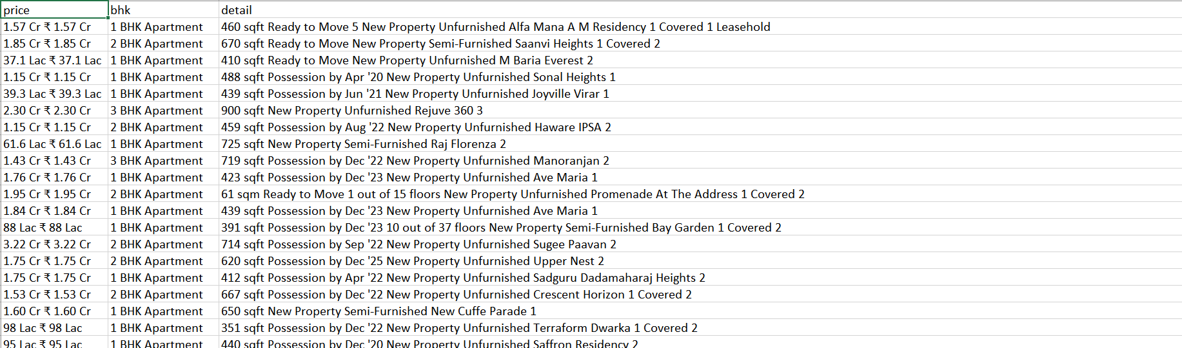

**Excel data Cleaning**

The above data need to get converted into appropriate number of columns which are as below:

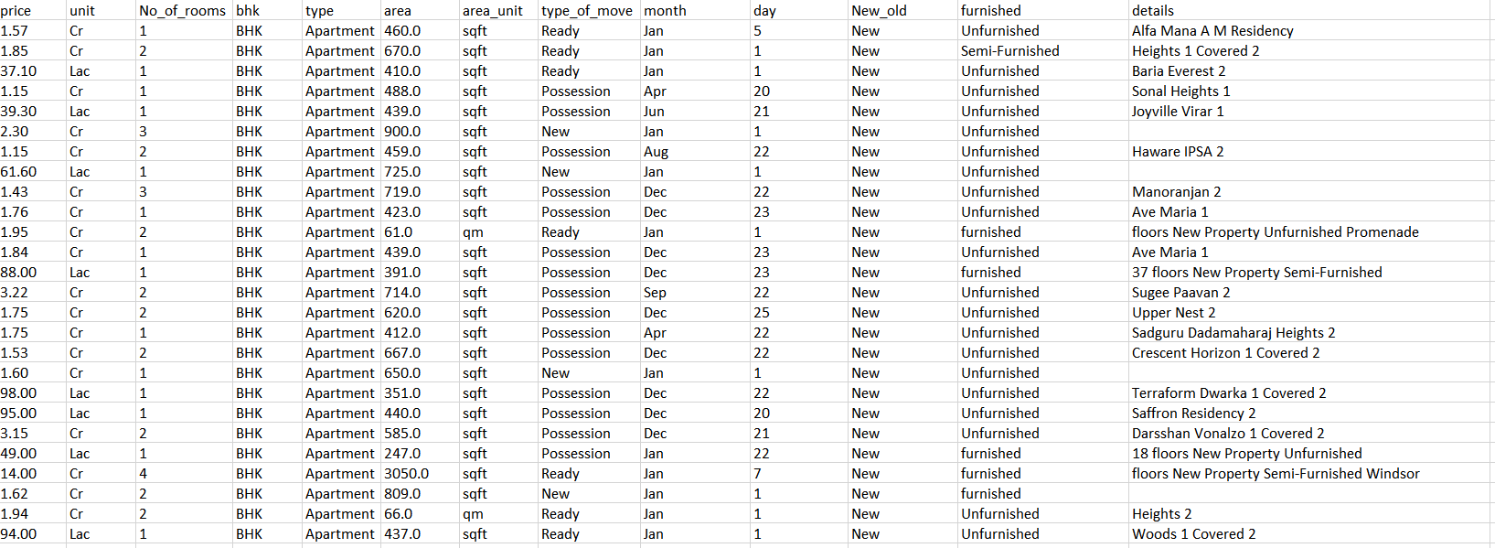

This was done with the help of the following tool present in excel:

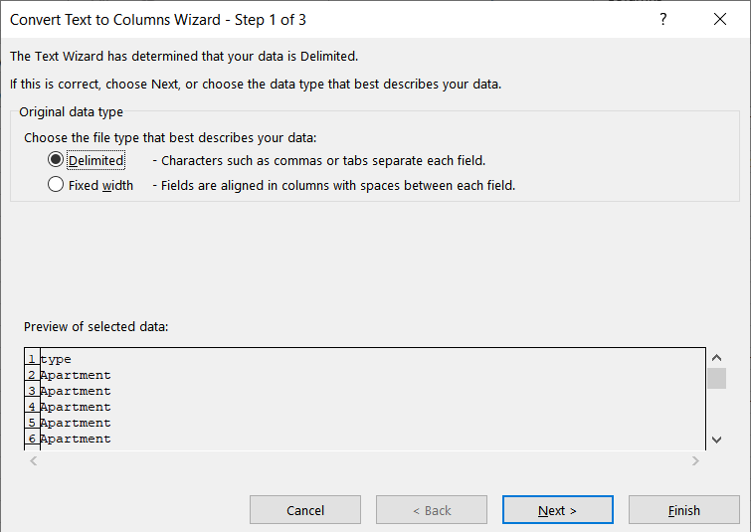

The above tool separated the columns into many columns according to the position. But there were some white space present in non uniform manner which converted numeric data into object type data. This was the issue to resolve it we have used a tool of excel ehich was downloaded externally which is as below:



**Python coding:**

**Library which are included as follows:**

import numpy as np

import pandas as pd

import sklearn.linear_model as lm

import matplotlib.pyplot as plt

from sklearn.linear_model import Ridge

from yellowbrick.regressor import ResidualsPlot

import warnings

%matplotlib inline

import seaborn as sns

**We read the csv file where data is stored by creating a dataframe as:**

df=pd. read_excel('"C:/Users/Lenovo/Desktop/real_estate_data.xlsx"')

df. head ()

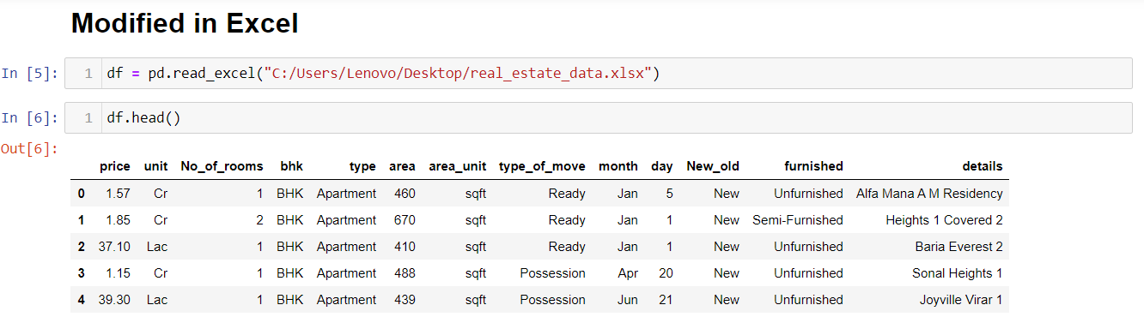

**Attribute with their count:**

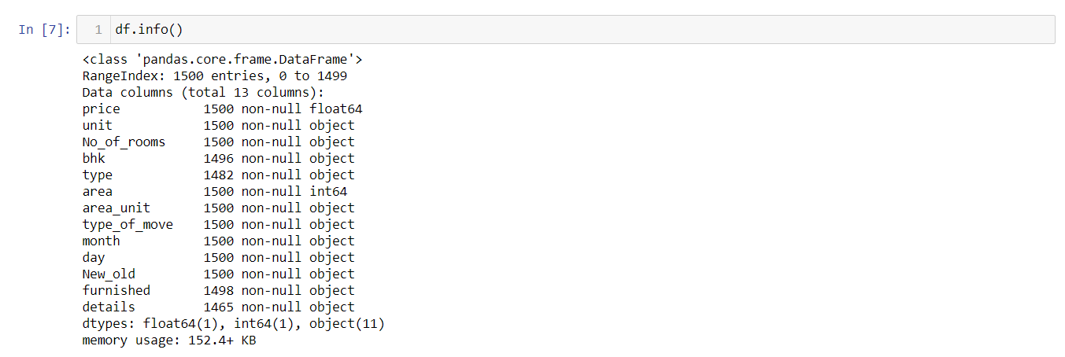

**Attribute with their null values:**

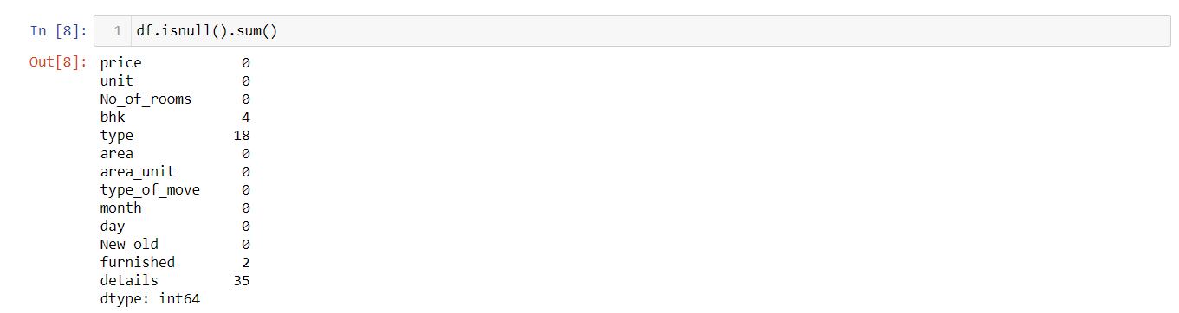

**Attribute with unique values(distinct values)**

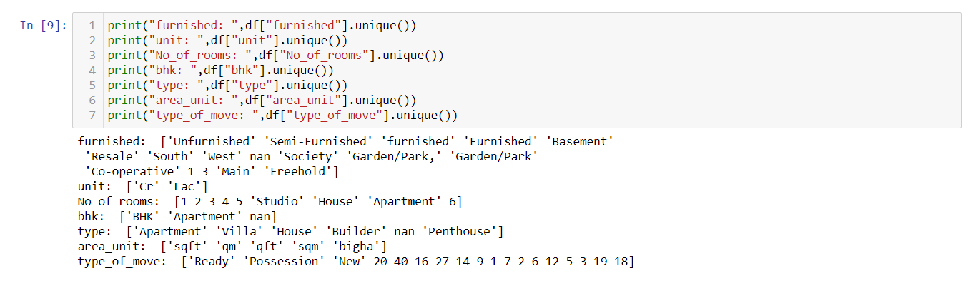

**Getting the description of the attribute and their details:**

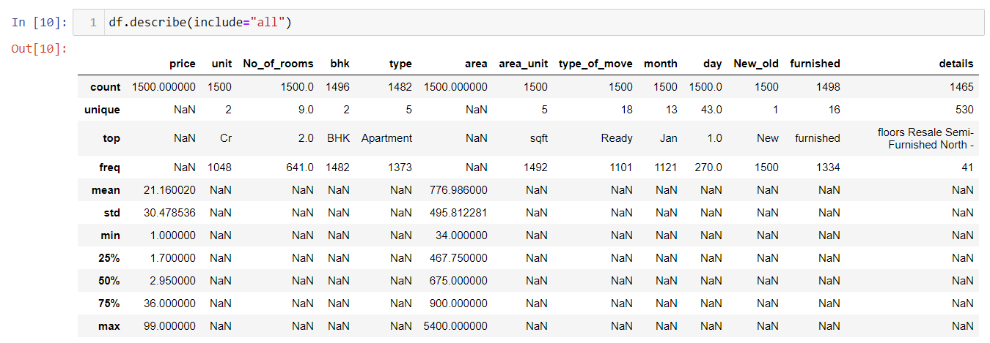

**Plotting each attribute:**

**AREA AND PRICE:(INTEGER)**

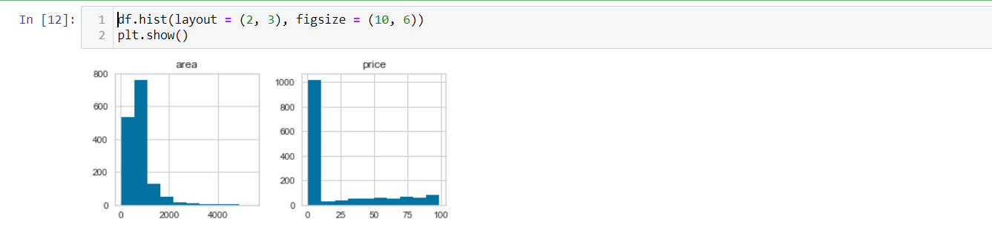

**PRICE UNIT(OBJECT)**

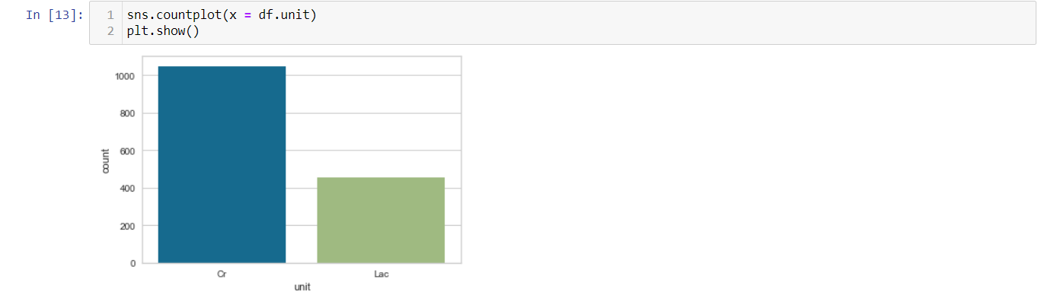

**NO OF ROOMS:**

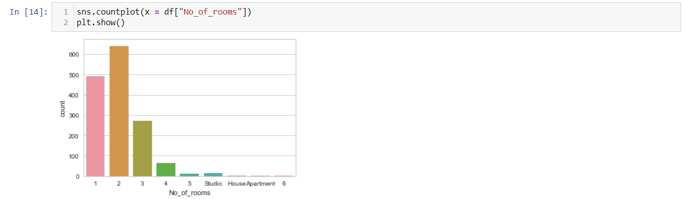

**TYPE OF BHK:**

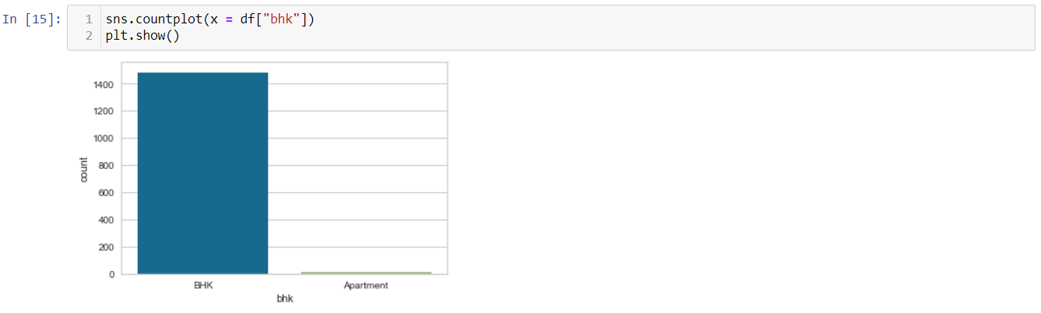

**TYPE OF HOUSE:**

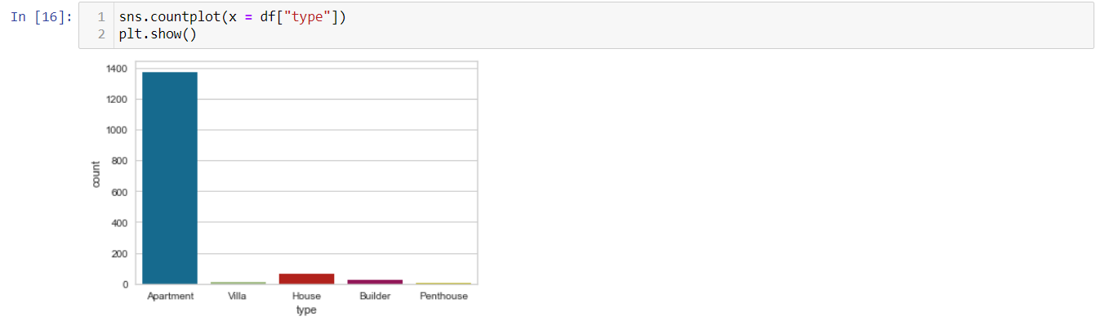

**POSSESSION TYPE:**

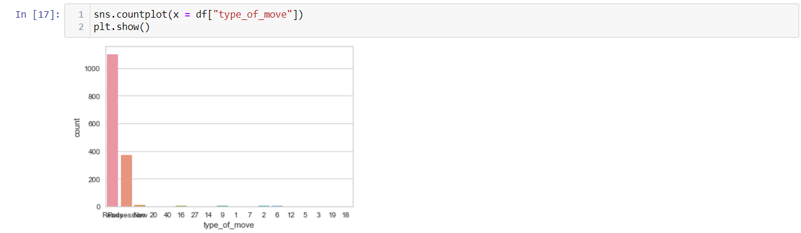

**OLD/NEW:**

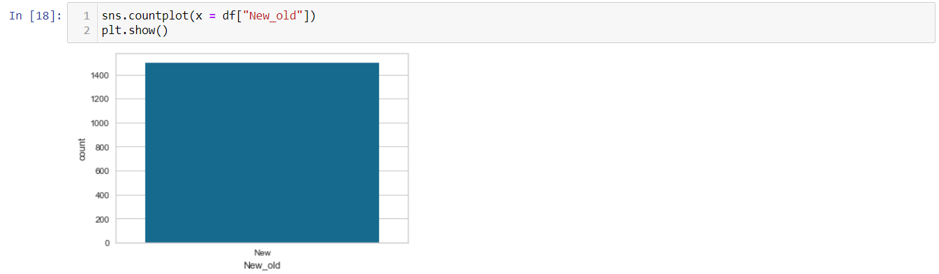

**FURNIESHED/ UNFURNIESHED**

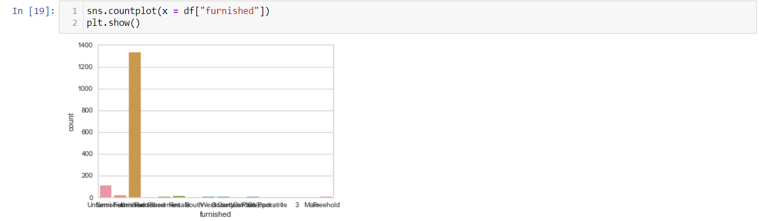

**EDA:**

**CONVERTING RUPEE IN ONE UNIT (LAKH TO CR):**

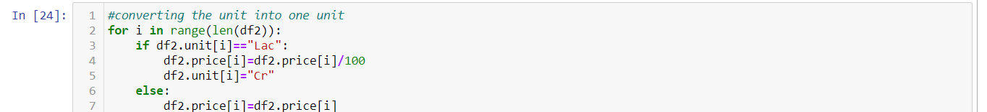

**CONVERTING ALL UNIT IN SQRT:**

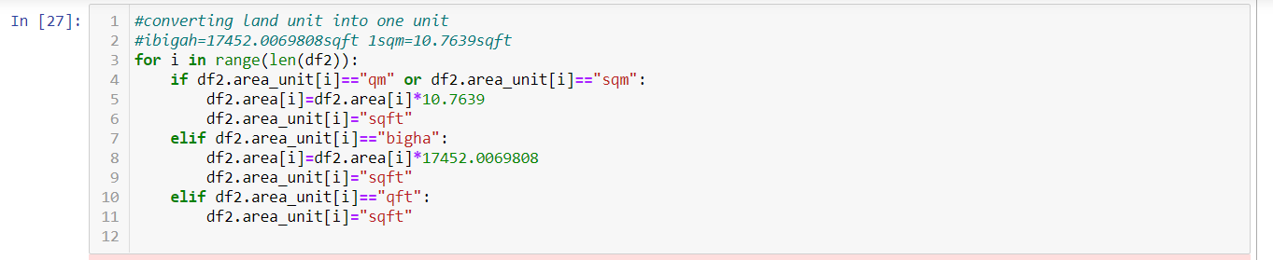

**GROUP PRICE ACCORDING TO NO. OF ROOMS.**

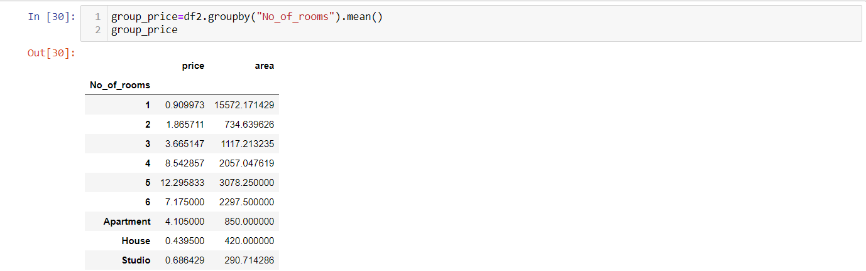

**FILLING THE SCRAMBLED ATRRIBUTE WITH FURNIESHED**

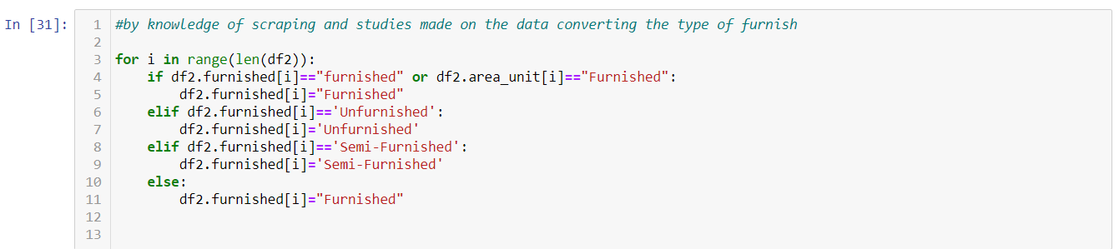

**COUNT OF NULL VALUES AFTER EDA**

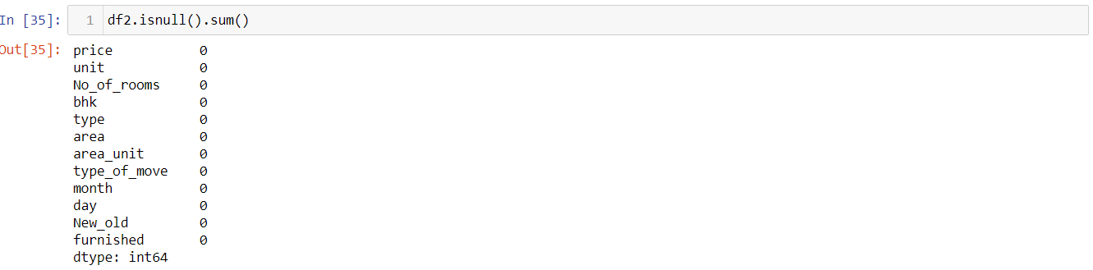

**GRAPHS AFTER EDA**

**NO. OF ROOMS COUNT:**

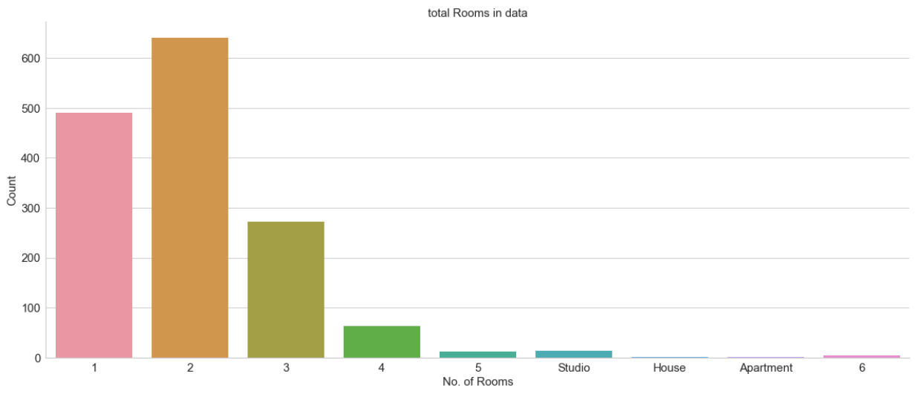

**FURNISHED/UNFURNISHED:**

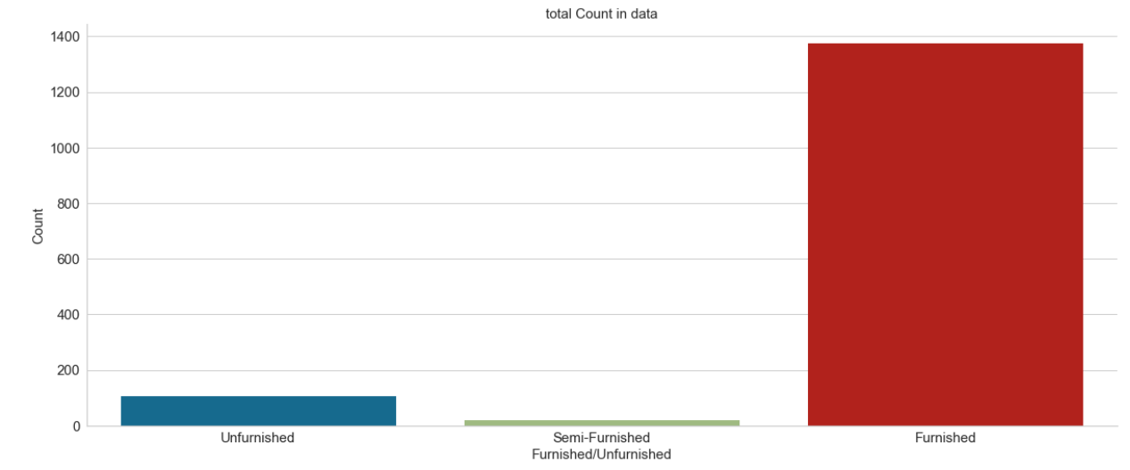

**Price Distribution and its box plot:**

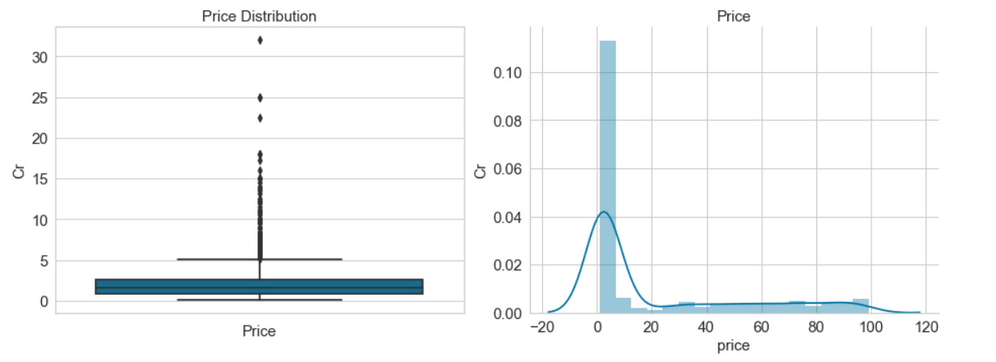

**Area distribution :**

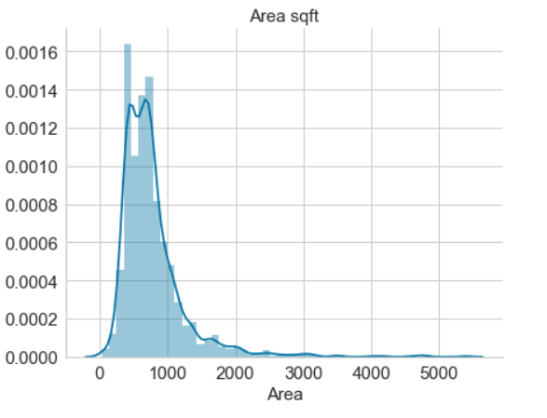

**Tried to add a column but found to disrupt linearity as it was found to have the output variable direct relation**

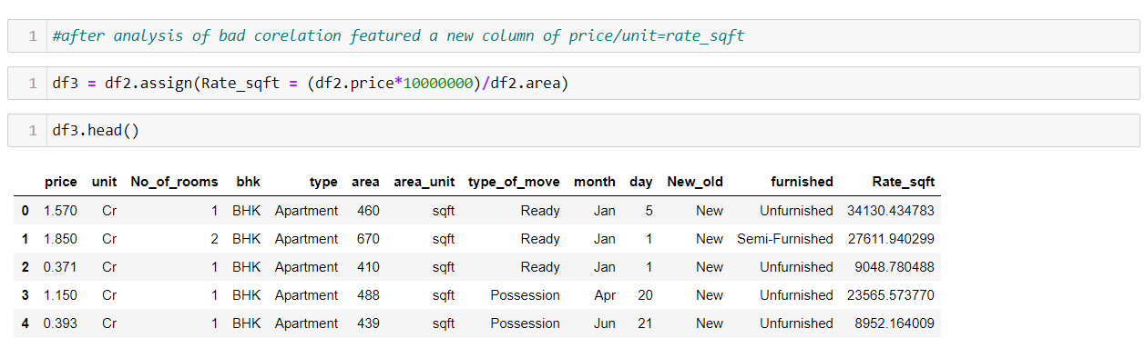

But this was found that it was depended on output so we dropped the idea.

After this our accuracy went to 90% + but it was of no use.

**We grouped according to the type of house:**

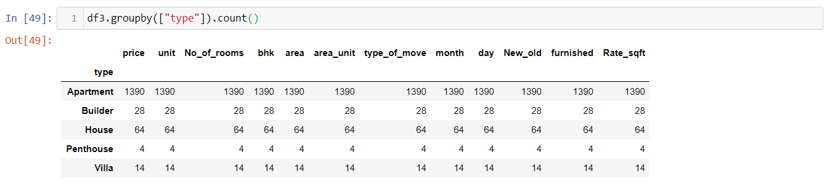

We found that all the interpretation of the house and all were having in sufficient data. With this all type of houses with all tuning parameters our accuracy with decision tree were par(<40%) below even by tuning of hyper parameters so we decided to take the majority of class as a whole sum

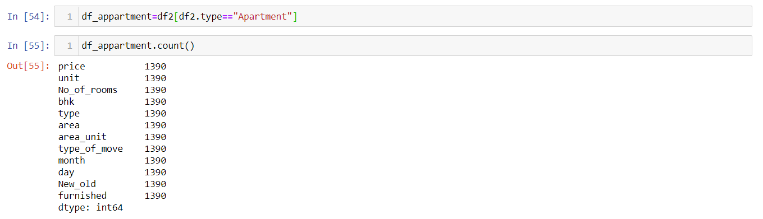

**Price distribution of apartment:**

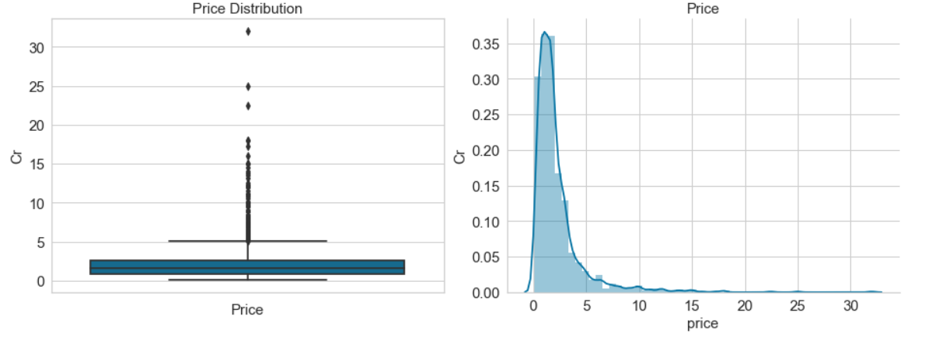

**The correlation:**

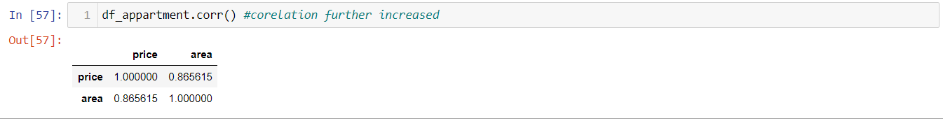

**Correlation graph:**

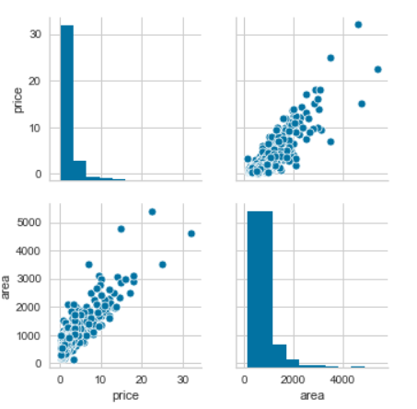

**Modeling :**

**For converting the categorical variable to train models we have to convert it into encoded variables which can be understood by the fit() function.**

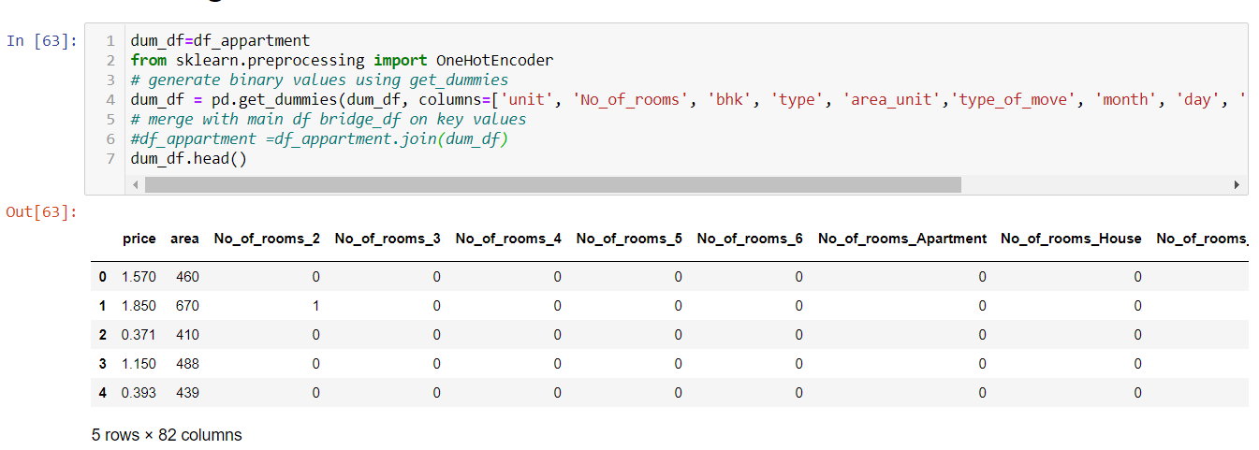

**VIF score:**

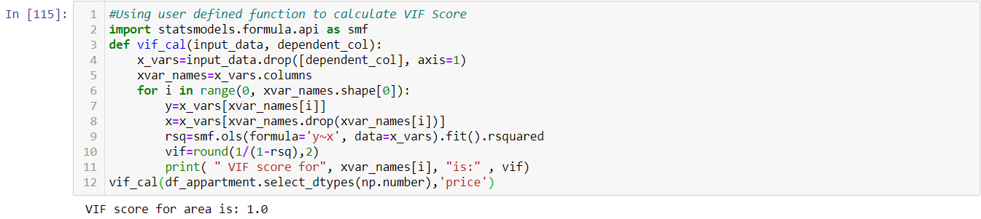

**Heat map:**

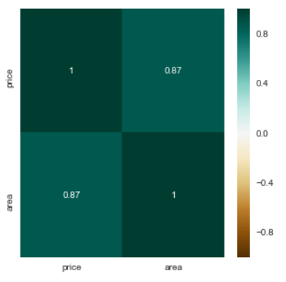

**MLR modeling and fitting:**

**X labels and y label:**



**Training and Testing Datasets:**



**Model training:**



**Train and test MSE:**

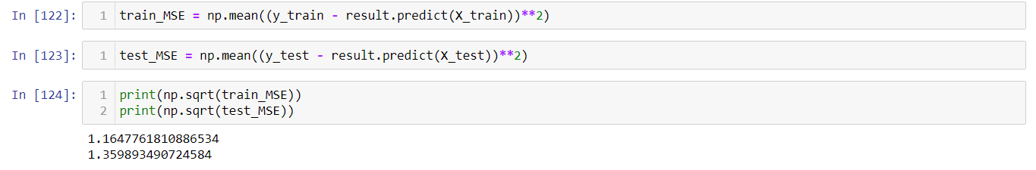

As the value of training and testing are almost same so there is no overfitting in the model.

**Accuracy:**



The accuracy is 77.9% even when the features are insufficient.

**Residual plot:**

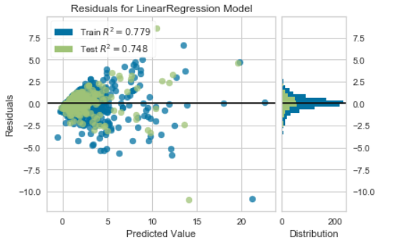

**Distribution is with in a certain area it violates one the assumption of the linear model. So it is our own risk whether we have work with this module or not.**

**Ridge & Lasso Regression**

Ridge and Lasso regression are some of the simple techniques to reduce model complexity and prevent over-fitting which may result from simple linear regression.

Ridge Regression***:***In ridge regression, the cost function is altered by adding a penalty equivalent to square of the magnitude of the coefficients

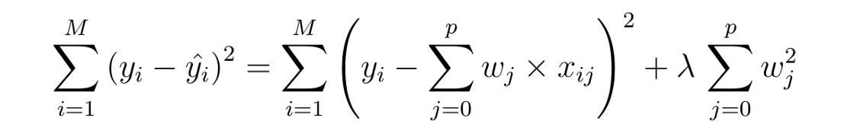

Lasso Regression: The cost function for Lasso (least absolute shrinkage and selection operator) regression can be written as

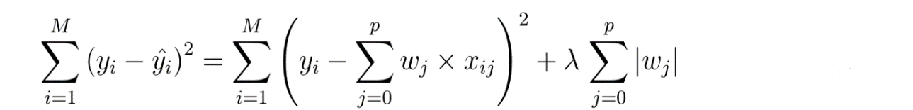

We import the required libraries and use GridSearchCV to get the best alpha value for optimizing coefficients in ridge regression. Higher the alpha value, more restriction on the coefficients; when alpha value is 0 linear and ridge regression resembles

**Ridge:**

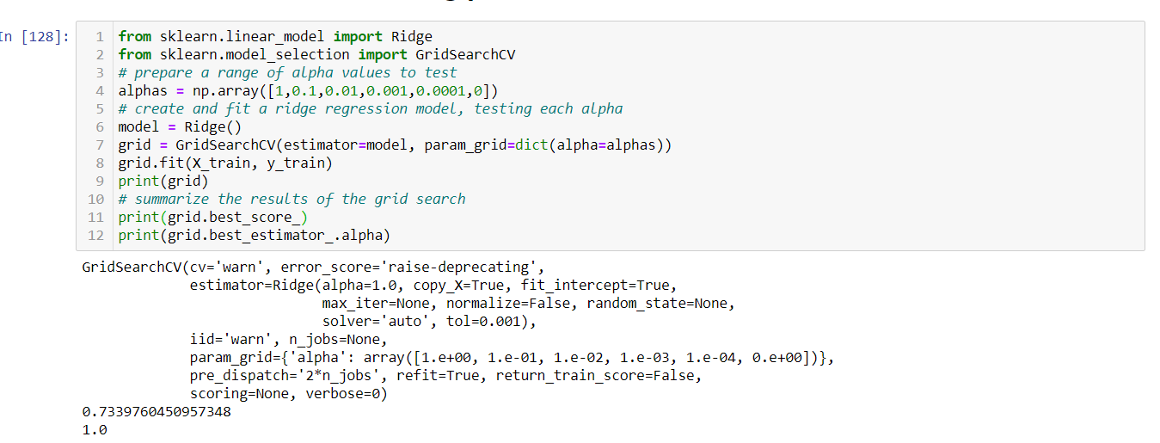

R-squared Training: 0.7497

R-squared Testing: 0.7475

Train RMSE : 1.2466

Test RMSE : 1.3358

Lasso regression can lead to zero coefficients i.e. some of the features are completely neglected for the evaluation of output. So, Lasso regression not only helps in reducing over-fitting but it can help us in feature selection

**Lasso:**

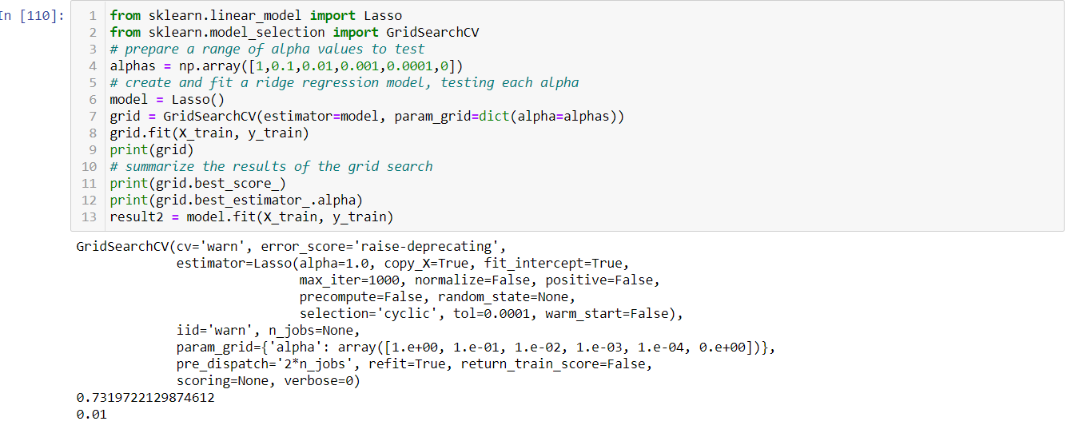

R-squared Training 0.7497

R-squared Testing 0.7475

Train RMSE : 1.2466

Test RMSE : 1.3358

**Bagged Decision Trees**

Many times, the single model does not perform well alone. In Ensemble learning multiple models (“weak learners”) are trained and combined to get improved results. Bagging, that often considers weak learners, learns them independently from each other in parallel and combines them following some kind of averaging process

We use binning for better sampling before applying bagging.

# Bagged Decision Tree:

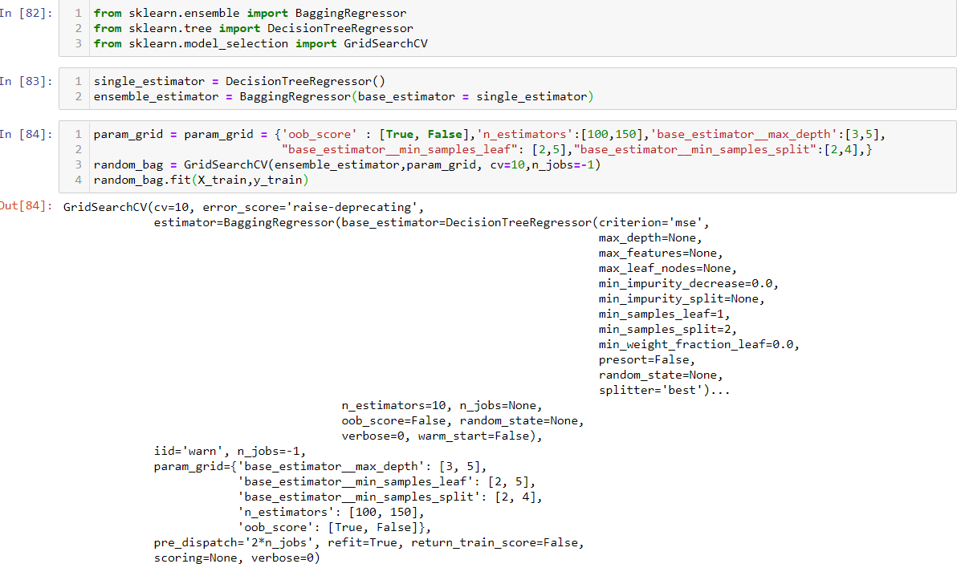

R-squared Training 0.8028937884960422

R-squared Testing 0.6873804017794123

Train RMSE : 1.15757418745997

Test RMSE : 1.213336537092128

# Bagging KNeighborsRegressor:

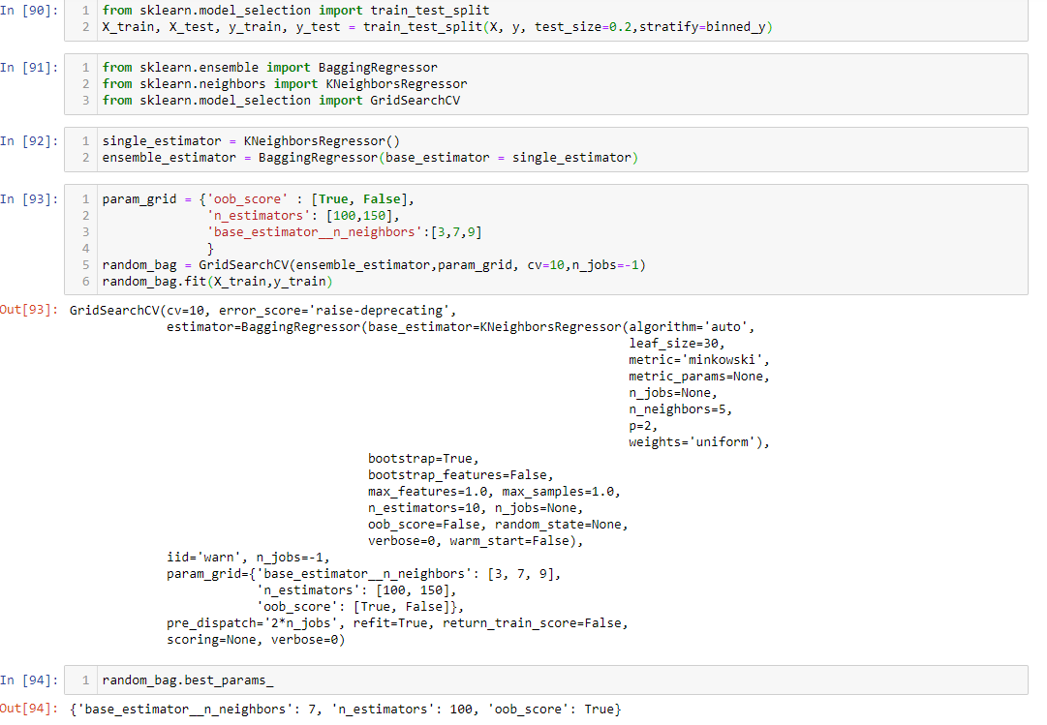

R-squared Training 0.8006

R-squared Testing 0.6900

Train RMSE : 1.1771

Test RMSE : 1.1245

SVR (LINEAR):

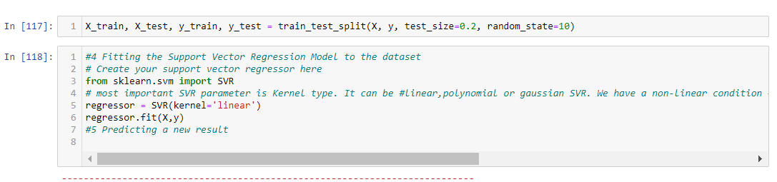

R-squared Training 0.7533

R-squared Testing 0.7702

Train RMSE : 1.2310

Test RMSE : 1.2986

**Gradient Boosting regression**

**Boosting** ensemble technique which considers weak learners, learns them sequentially in a very adaptative way (base model depends on the previous ones) and combines them following a deterministic strategy. gradient boosting combines weak "learners” into a single strong learner in an iterative fashion. Decision trees are used as the weak learner in gradient boosting

The parameters that can be tuned are similar to the decision tree regressor explained above but in addition we need to specify

* n_estimators:- Number of trees to be added
* 'learning rate' is a tuning parameter in an optimization algorithm that determines the step size at each iteration while moving toward a minimum of a loss function
* There is a trade-off between learning rate and n_estimators.

Gradient Boosting Regression:

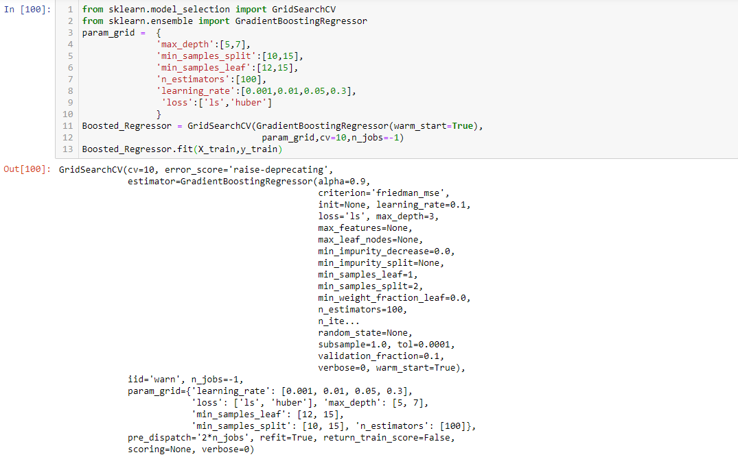

R-squared Training 0.7719

R-squared Testing 0.7919

Train RMSE : 1.1900

Test RMSE : 1.2125

Decision-Tree Regression

Regression trees are used when the dependent variable is continuous. For regression trees, the value of terminal nodes is the mean of the observations falling in that region. Therefore, if an unseen data point falls in that region, we predict using the mean value. Decision tree algorithms can be applied to both regression and classification tasks; in this project we have done a simple regression implementation using Python and scikit-learn.

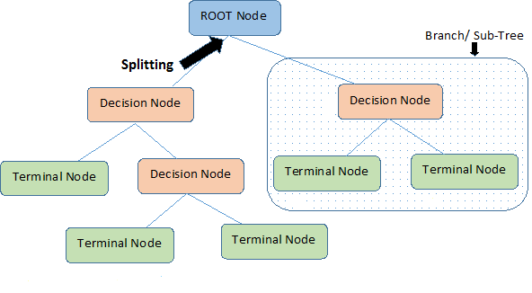

**Decision Tree Parameters**

**criterion**: This parameter determines how the impurity of a split will be measured.

**max_depth:**This determines the maximum depth of the tree. The default value is set to none. This will often result in over-fitted decision trees. The depth parameter is one of the ways in which we can regularize the tree, or limit the way it grows to prevent **over-fitting**.

**min_samples_split:**The minimum number of samples a node must contain in order to consider splitting. The default value is two.

**min_samples_leaf:**The minimum number of samples needed to be considered a leaf node. The default value is set to one. Use this parameter to limit the growth of the tree

We fit the tree with the following best parameters as obtained by GridSearchCV.

**Decision tree regressor with pipeline and standard scalar transformation :**

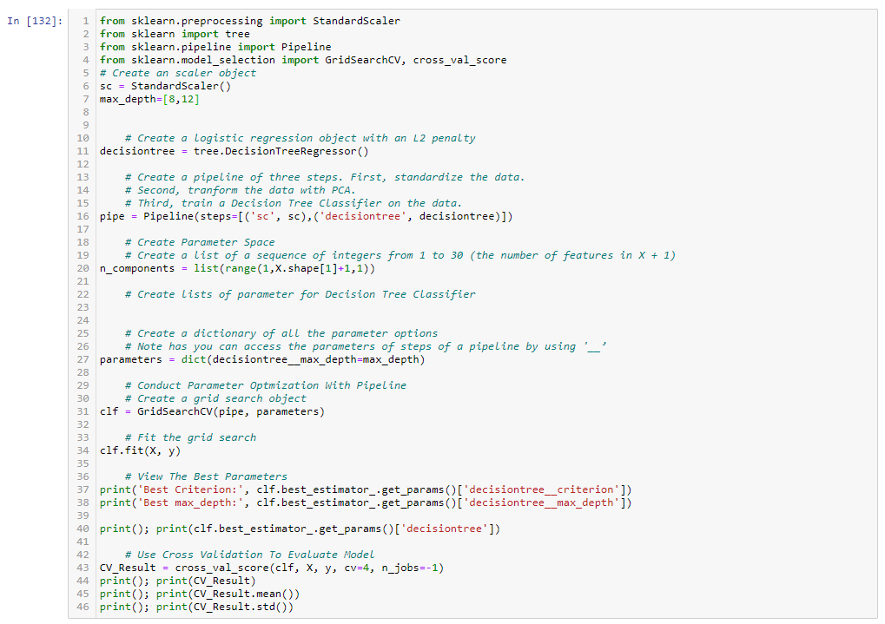

|  |  |  |  |  |
| --- | --- | --- | --- | --- |
| **MODEL** | **TRAIN RMSE** | **TEST RMSE** | **TRAIN ACC.** | **TEST ACC.** |
| **MLR** | **1.1647** | **1.3598** | **0.7791** | **0.7480** |
| **LASSO** | **1.2466** | **1.3358** | **0.7497** | **0.7475** |
| **RIDGE** | **1.1846** | **1.3071** | **0.7740** | **0.7584** |
| **BAGG. D.T.** | **1.1575** | **1.2133** | **0.8028** | **0.6873** |
| **BAGG. KNNR** | **1.1771** | **1.1245** | **0.8006** | **0.6900** |
| **GRADIENT BOOSTING REGRESSION** | **1.1900** | **1.2125** | **0.7719** | **0.7919** |
| **SVR** | **1.2310** | **1.2986** | **0.7533** | **0.7702** |

|  |  |  |  |  |
| --- | --- | --- | --- | --- |
|  | WITH ALL THE ACCURACY SCORE WE CAN SAY THAT ALL THE MODEL HAVE A MODERATE ACCURACY AND WE CAN CHOOSE ANY OF THEM WITH HAVING ACCURACY OF MORE THAN 70% IN EACH OF THEM |  | THE BEST OF ALL CAN BE SAID TO GRADIENT BOOSTING REGRESSION |  |

SOME OF THE MAJOR PROBLEM FACED:

DATA IS SCEWED AND STANDARD SCALAR SHOULD BE APPLIED AS THERE IS A UNIT DIFFERENCE BUT AS WE APPLIED IT THE ACCURACY DECRESED DRASTICALLY.

INFORMATION WHICH WAS NEEDED WERE NOT ABLE TO SCRAPED FROM THE WEBSITE.

WE WERE HAVING JUST ONE NUMERICAL COLUMN AND NEEDED TO MAINTAIN IT.

CLEANING OF DATA TOOK MAJOR PART.

WE APPLIED OUR MODLE TO WHOLE DATA SET HAVING DIFFERENT TYPES OF HOUSES BUT THE ACCURACY WHICH WAS THERE WAS EVEN LESS THAN 15%.

|  |  |  |  |  |  |  |
| --- | --- | --- | --- | --- | --- | --- |
|  |  | | | | |  |
|  | |  |  |  |  | |
|  |  | | | | |  |